Name: Kareem El Sayed

CS370 Software Engineering

USER MANUAL

www.Kaiyo.com

List of contents

1.Input/Output from command line

2.Register or Sign in

3.Gui functionality

4.Online Search function

5.Stores data Offline queries

6.Offline queries Transaction log

7.Transaction log

8.Process individual data from pages
Installation

Download project folder. Using a command prompt. Change directories into project folder from Desktop. Follow all steps provided in README.txt which is provided with the project folder.

1.Input/Output from Command Prompt

2.Register or Sign in

3.Gui Functionality

This GUI will appear once program is compiled and run successfully.

Commands from README.txt are

Step 1: Inside the project folder type the following command

javac -d . -cp . Main.java

Step 2: After compilation of step 1 then run the following command

java -cp . Main -i data/query.txt -o data/results.txt
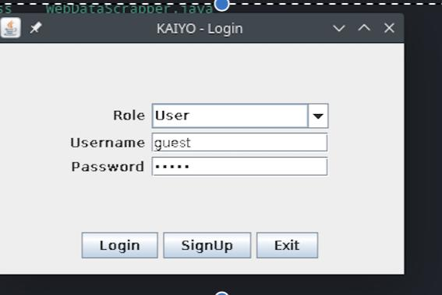

SIGN UP / LOG-IN

The program will save your information to first time users unless user logs in as a guest.

This should appear after
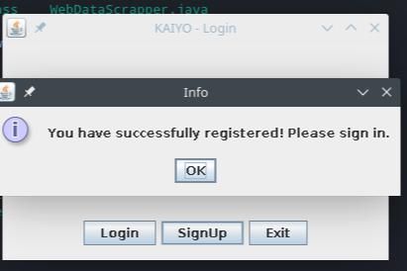

SUCCESS

4.Online Search Function

5.Storage of data

After login, User can start by searching for item. This search will also be saved.
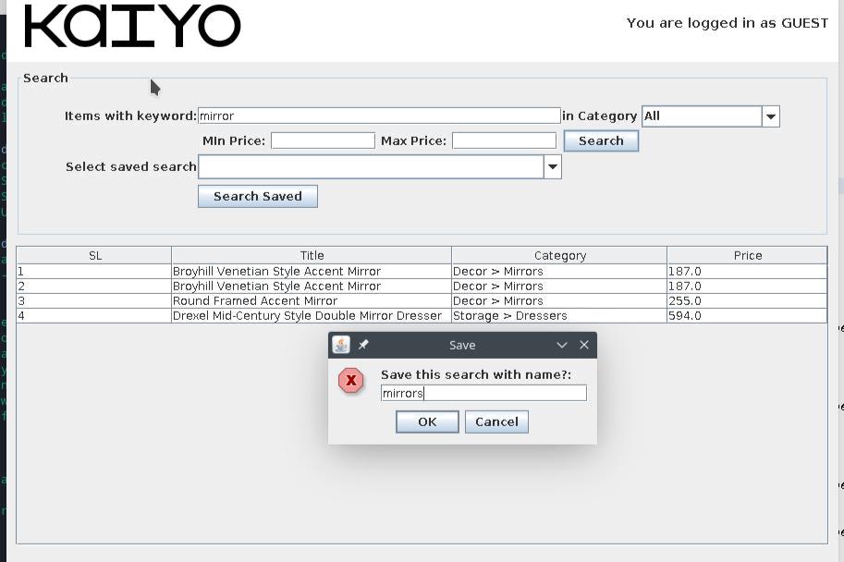

SEARCH MIRRORS/ SEARCH BED WITH OPTION TO SAVE IN DATABASE. THIS WILL ALSO BE INCLUDED IN THE TRANSACTION LOG.
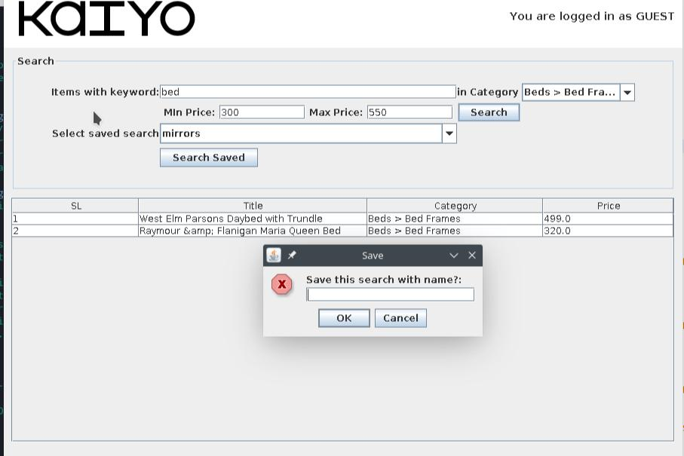
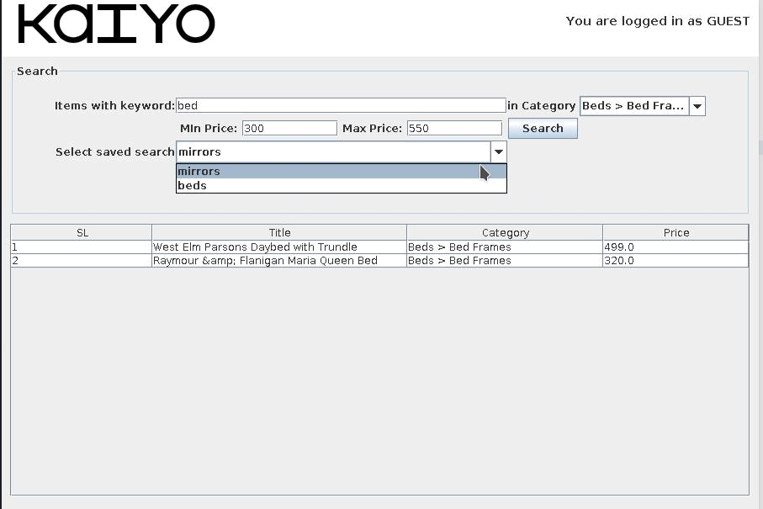

SAVE SEARCH RESULTS

6.Storage of data

7.Transaction log

8.Offline Queries

All above database files are serialized data of instances UsersDB, ItemsDB and TransactionsDB respectively.

Note:

- No database files will be there inside data/ folder when project run for first time
- On first run the project will scrap all items from the website and store them in ItemsDB class instance
- If step 2 is run with -p flag at the end of the argument on command prompt then ItemsDB is not saved to database file, else its written

Screenshot of a stored item from GUI
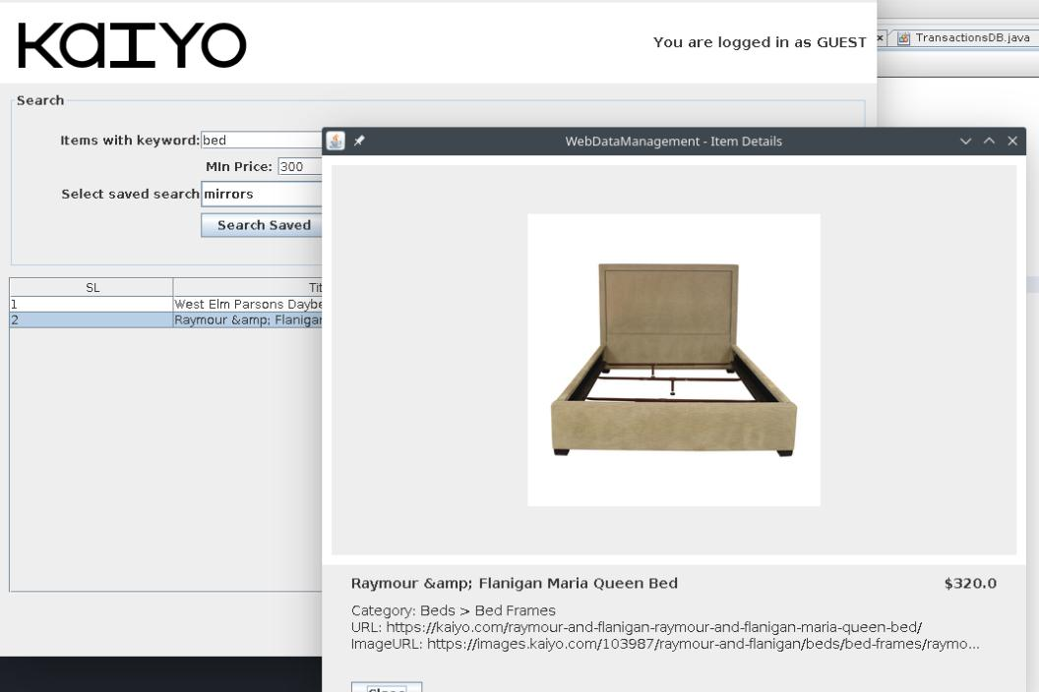

ITEM DETAILS OF A BED FROM THE SITE

More screenshots of GUI functionality
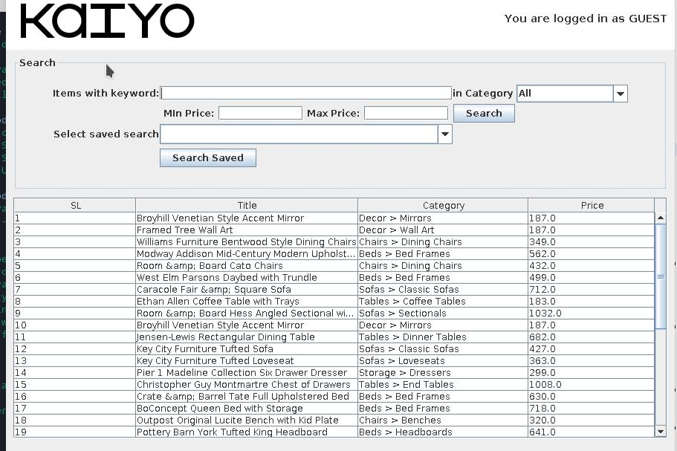

MAINSCREEN FOR GUEST LOGIN
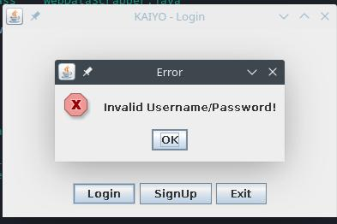

INCASE OF INVALID LOGIN

